# How to: Access Oracle DB in Power BI

Make sure you have a gateway set

Go to Power BI in office.com

Create a workspace (in this example, OracleMPDData is created)

Create a dataflow

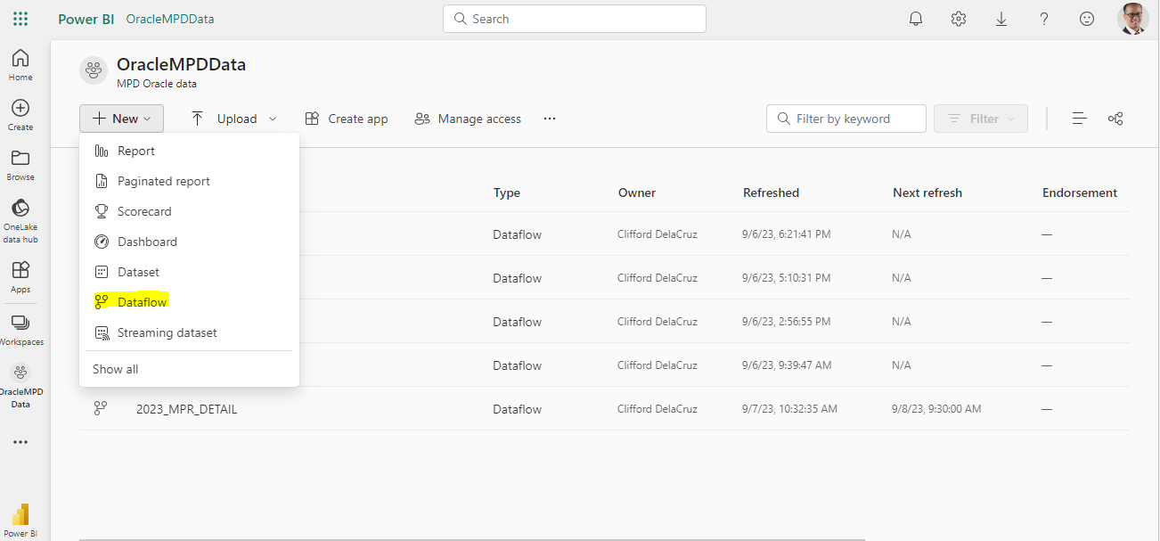

Select “Add new tables”

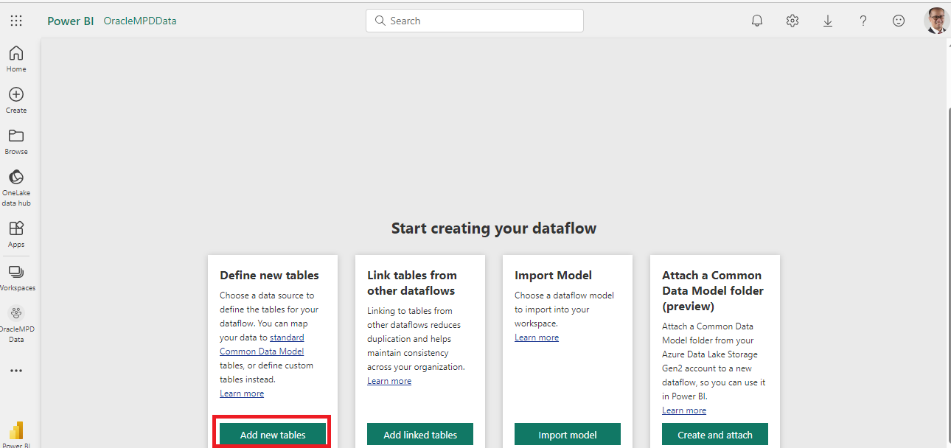

Select Oracle database

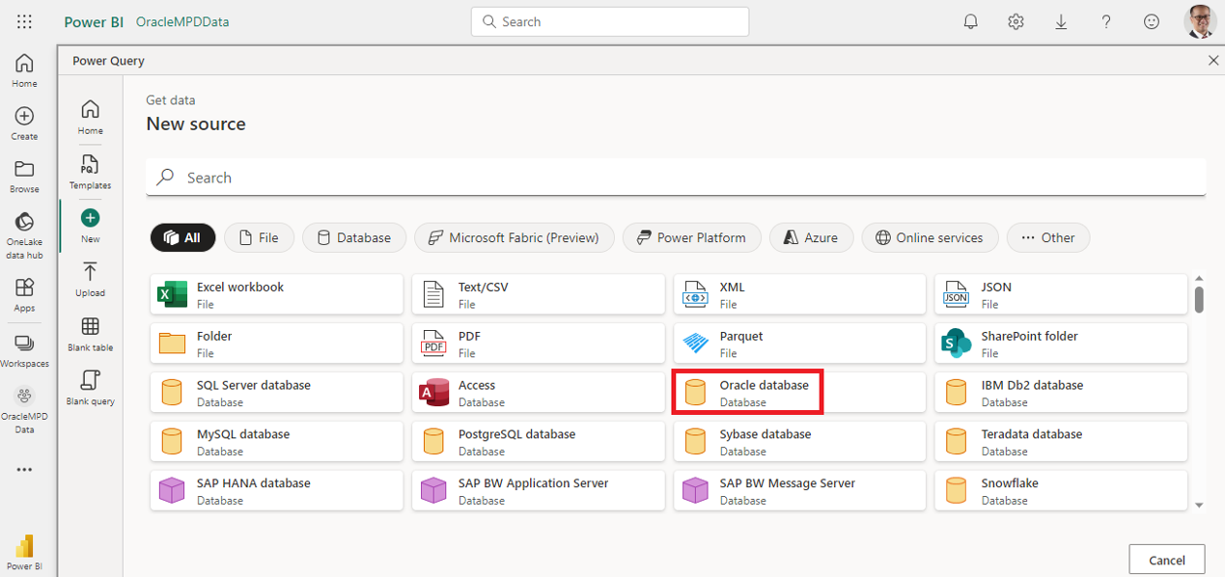

Input the server you need to connect to.

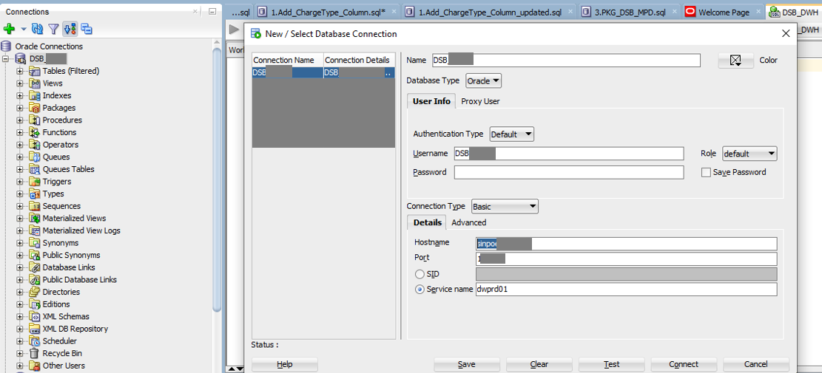

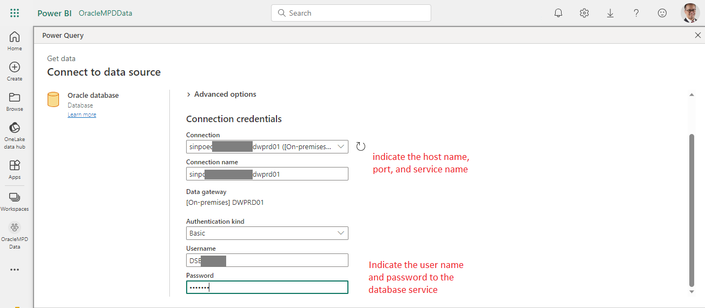

Next screen, select the database and table you need to connect. Proceed and click “Transform data”.

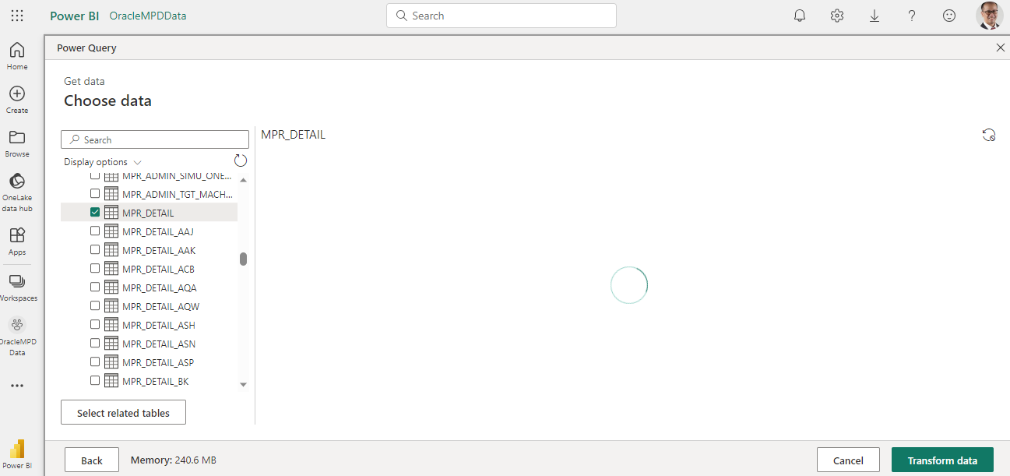

Perform necessary cleaning and transformation

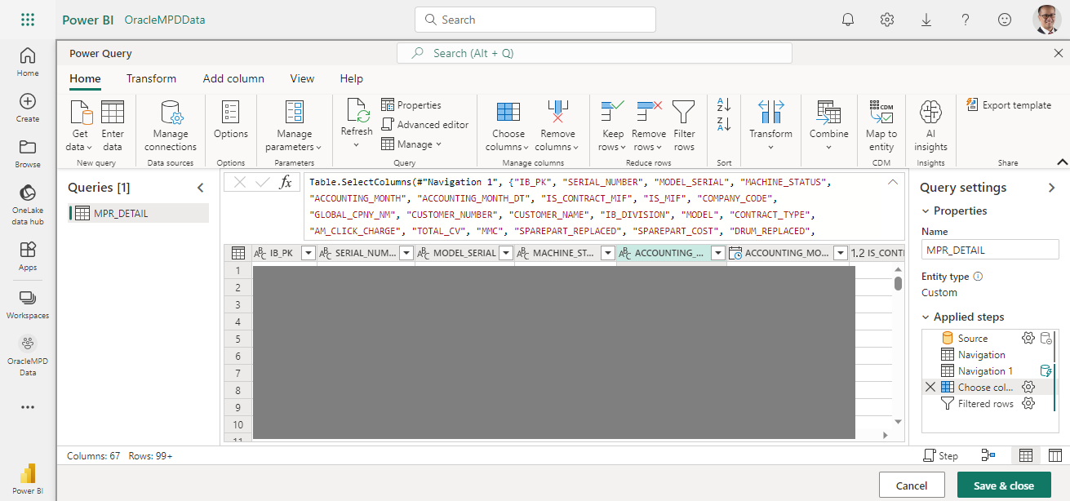

Save and refresh the dataflow

